Offline AI Study App: Production Architecture
Oct 10, 2026 · @Kesavan M
A React Native app with a shared C++ core that runs a quantized 1–4B LLM (llama.cpp) and a local RAG pipeline (ONNX embeddings + SQLite vectors), fully offline after the first model download.

Scope and key decisions
The app works with no internet after the first model download, and no user text, document or chat ever leaves the phone. These decisions are fixed before any code is written:
- Platform: Android first (widest range of RAM tiers in India), iOS in phase 3 from the same C++ core.
- UI: React Native (New Architecture, TypeScript). Heavy work (LLM, embeddings, PDF parsing) runs in native C++ behind JSI / TurboModules, never on the JS thread.
- Runtime: llama.cpp with GGUF Q4_K_M models. One engine for chat and RAG answers.
- Retrieval: embeddings from a small local model, vectors in SQLite, hybrid search (vector + keyword).
- Delivery: the APK ships with no model. Models download on first launch over Wi-Fi, with resume and checksum.
- Languages: global launch, English first. Other languages (Tamil, Hindi, Spanish) are added one at a time, each only after it passes a per-model quality test.
- Business model: free tier with one small model and 3 documents; Pro subscription (₹49 per month, plus yearly and lifetime options) with regional pricing. Users bring their own documents; there are no study packs.

At a glance
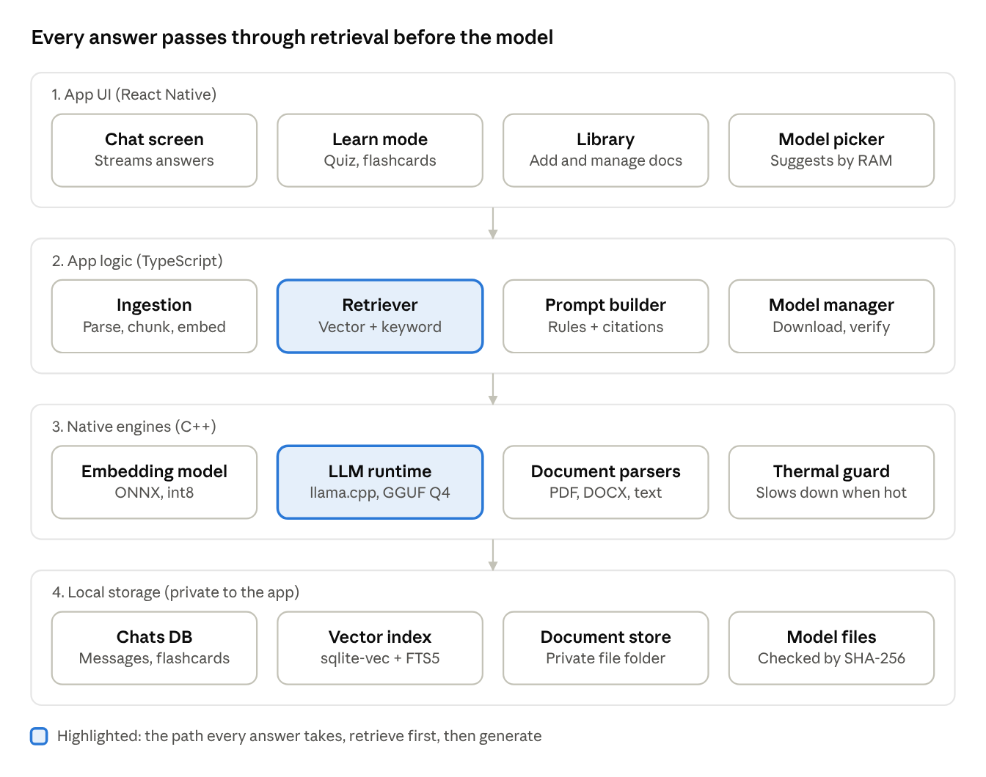
architecture · 4 layers
A question moves down from the UI: the retriever finds the best chunks, the prompt builder adds them with the answer rules, and the on-device LLM writes the cited answer. Every layer runs on the phone.

Tech stack
Layer | Choice | Why
UI | React Native (New Architecture) + TypeScript + Zustand | One codebase for Android and iOS, testable state
Native bridge | C++ core via JSI / TurboModules, run on a native background thread | Keeps the JS thread free so the UI stays smooth while tokens stream
LLM runtime | llama.cpp via llama.rn (GGUF, Q4_K_M) | Best mobile coverage, ARM NEON/i8mm kernels, active upstream
Embeddings | A small GGUF embedding model through llama.rn (ONNX Runtime Mobile int8 as a fallback) | 30–120 MB, fast on CPU; the e5 model covers about 100 languages
Vector store | SQLite via op-sqlite, FTS5 for keywords, brute-force cosine over stored vectors (sqlite-vec later) | One file, transactional, no extra server
PDF / text parsing | PdfBox-Android for text and PdfRenderer to show pages (Android), PDFKit (iOS later), plain-text parsers | Android's PdfRenderer cannot extract text, so PdfBox-Android does it
OCR (phase 2) | ML Kit on-device text recognition | Scanned notes and textbooks
Model download | WorkManager + HTTP range requests, SHA-256 check | Survives app kill, resumes after network loss
Crash and metrics | Local logs; opt-in anonymous crash reports only | Keeps the privacy promise

RAG pipeline
Small models (1–3B) hallucinate, so every answer is forced to come from retrieved text and must cite it.
Ingestion (runs once per document, in a background service with a progress notification)
- Parse the file to text per page, keeping page numbers.
- Clean: remove headers, footers and hyphenation breaks.
- Chunk at 350 tokens with 60 overlap, splitting on headings and paragraphs first, sentences second.
- Embed in batches of 16; store chunk text, page, vector and an FTS5 row in one transaction.
- Mark the document ready. A killed run resumes from the last committed batch.
Query (target: first token under 4 s on a 6 GB phone)
- Rewrite the question using the last 2 turns so follow-ups like "explain that again" retrieve correctly.
- Embed the query, take the top 20 by vector and the top 20 by FTS5 keyword match, merge with reciprocal rank fusion.
- Keep the best 4 chunks within a 1,500-token context budget.
- Build the prompt: system rules, the chunks labelled [1]–[4] with page numbers, recent chat, the question.
- Stream tokens to the UI. Show the sources as tappable chips that open the PDF at that page.
- If the best similarity score is below the threshold, answer "I could not find this in your notes" instead of guessing.
System prompt rules (tested per model)
- Answer only from the numbered context and cite the numbers.
- If the context is not enough, say so.
- Reply in the language of the question.
- Keep answers short unless the learner asks for detail.
Learn mode features built on the same pipeline
- Quiz and flashcards: ask the model for questions over a chunk, then validate the JSON output with a grammar-constrained sampler.
- Summaries: map-reduce over chunks, 1 chunk per call, saved so they are not recomputed.
- Spaced repetition: SM-2 schedule stored in SQLite, local notifications for reviews.

On-device LLM
The model manager reads total RAM, free RAM, CPU ABI and chip class at first launch and recommends one model. Sizes below are approximate Q4_K_M file sizes from memory; verify each against the model card and licence before shipping.
Phone RAM | Recommended | Also offer | File size (approx.) | Expected speed
3–4 GB | Qwen2.5 1.5B Instruct | Qwen2.5 0.5B, Llama 3.2 1B | 0.4–1.1 GB | 8–15 tok/s
6 GB | Qwen2.5 3B or Llama 3.2 3B | Gemma 3 1B | 1–2 GB | 5–10 tok/s
8 GB | Gemma 3 4B or Phi-4-mini | Qwen2.5 3B | 2–2.7 GB | 4–8 tok/s
12 GB and up | Qwen2.5 7B Instruct | Gemma 3 4B | about 4.7 GB | 2–5 tok/s
Speeds are rough mid-range Snapdragon numbers; the benchmark in the quality section replaces them with measured values.
Runtime settings
- Context window: 2,048 tokens on 4 GB phones, 4,096 on 6 GB and above. Larger contexts cost RAM through the KV cache.
- Threads: performance cores only (usually 4); more threads slow down on big.LITTLE chips.
- Memory: load the GGUF with mmap so the OS can reclaim pages; keep the model loaded only while the chat screen is open, unload after 2 minutes idle.
- Thermal: read battery temperature and thermal status; above the limit, lower threads and show a "cooling down" notice instead of throttling silently.
- Safety net: a native crash in inference can end the app, so the app records an unclean exit and, on the next launch, offers a smaller context or model.
Model delivery
- Catalog is a signed JSON file (id, URL, size, SHA-256, min RAM, licence, languages) fetched on launch when online and cached.
- Download only on Wi-Fi by default, show size before starting, verify checksum, delete the partial file on mismatch.
- Models live in app-private storage and can be removed from Settings to free space.

Data model
One SQLite database in app-private storage, protected by the Android app sandbox (SQLCipher can be added later). Schema changes ship as numbered migrations.
CREATE TABLE document (
id INTEGER PRIMARY KEY,
title TEXT NOT NULL,
path TEXT NOT NULL,
mime TEXT,
pages INTEGER,
status TEXT CHECK (status IN ('queued','indexing','ready','failed')),
embed_model TEXT NOT NULL,
created_at INTEGER NOT NULL
);
CREATE TABLE chunk (
id INTEGER PRIMARY KEY,
document_id INTEGER NOT NULL REFERENCES document(id) ON DELETE CASCADE,
ordinal INTEGER NOT NULL,
page INTEGER,
text TEXT NOT NULL
);
CREATE VIRTUAL TABLE chunk_fts USING fts5(text, content='chunk', content_rowid='id');
-- MVP: add an embedding BLOB column to chunk and search it by cosine similarity (see the build spec)
CREATE TABLE conversation (
id INTEGER PRIMARY KEY,
title TEXT,
model_id TEXT NOT NULL,
scope TEXT,
updated_at INTEGER NOT NULL
);
CREATE TABLE message (
id INTEGER PRIMARY KEY,
conversation_id INTEGER NOT NULL REFERENCES conversation(id) ON DELETE CASCADE,
role TEXT CHECK (role IN ('user','assistant','system')),
content TEXT NOT NULL,
sources TEXT,
tokens INTEGER,
created_at INTEGER NOT NULL
);
CREATE TABLE flashcard (
id INTEGER PRIMARY KEY,
chunk_id INTEGER REFERENCES chunk(id) ON DELETE SET NULL,
question TEXT NOT NULL,
answer TEXT NOT NULL,
ease REAL DEFAULT 2.5,
interval_days INTEGER DEFAULT 0,
due_at INTEGER
);
The vector size (384) matches bge-small; multilingual-e5-small is also 384. Changing the embedding model means re-indexing, so each document stores embed_model and the app re-embeds in the background when it changes.

Quality, performance and battery
Targets below are starting goals; they are measured on three reference phones (4 GB, 6 GB, 8 GB) before each release.
Metric | Target | How to measure
Time to first token (6 GB phone) | under 4 s | In-app benchmark, 50 questions
Generation speed (3B model) | 5 tok/s or more | llama.cpp bench on device
Indexing speed | 100 pages in under 3 min | Timed ingestion of a fixed PDF set
Answer grounded in context | 90% or more | Golden set of 100 questions with expected pages
Retrieval hit rate (right page in top 4) | 85% or more | Same golden set, no LLM needed
Refusal when answer is absent | 90% or more | 30 out-of-scope questions
Cold start to chat screen | under 2 s | Android Studio profiler
Battery per 10-minute chat | under 6% | Battery Historian on reference phones
Crash-free sessions | 99.5% or more | Opt-in crash reports, Play vitals
Evaluation loop
- Keep a golden set of questions with the expected source page for English notes first, then for each added language.
- Run retrieval metrics in CI on every change to chunking or embeddings.
- Run the full answer evaluation on a device farm before each release, scoring with a fixed larger model offline, never in the app.
- A model enters the catalog only if it passes the grounded-answer and refusal targets in every language it is offered for.

Security, privacy and licensing
Privacy
- No network permission is used after setup except model download; the app works with airplane mode on.
- App-private storage protected by the Android sandbox; database encryption (SQLCipher, key in Android Keystore) is a later hardening step.
- Documents are copied into app-private storage; a "delete everything" button removes files, vectors and chats.
- Analytics and crash reports are off by default and opt-in, with no document or chat text ever included.
- Backup rules exclude the database and models, so nothing is uploaded to cloud backup by accident.
Integrity
- Model and study-pack downloads are verified by SHA-256 from a signed catalog.
- The model catalog is data only (signed JSON); no executable code is downloaded or loaded.
- Uploaded documents are untrusted input: cap file size, parse in a try/catch with timeouts, and treat text inside a document as data, so a line like "ignore previous instructions" cannot change the system prompt rules.
Licensing (check before launch, terms change)
- Each model has its own licence (Apache 2.0, Llama community licence, Gemma terms). The catalog stores the licence and the app shows attribution and required notices.
- Gemma and Llama licences carry use conditions; get them reviewed before charging for the app.
- Users add their own documents, which stay on the device and are never uploaded. The app ships no third-party textbook content.
- Play Store Data safety form: declare that data stays on device.

Build, release and monetization
Repository layout
app/ React Native UI (TypeScript), state, navigation, l10n (English first, more languages later)
core/ C++ library: llama.cpp wrapper, embeddings, chunker, vector search
platform/ Android (Kotlin: service, WorkManager, Keystore), iOS (Swift)
catalog/ signed model catalog + signing tool
eval/ golden sets, retrieval and answer evaluation scripts
CI/CD
- GitHub Actions builds the C++ core for arm64-v8a (and armeabi-v7a only if the data justifies it), runs unit tests, retrieval evaluation and Jest and Detox tests on every pull request.
- Release builds ship as an Android App Bundle, signed by Play App Signing, via internal, closed and then production tracks with staged rollout (5%, 20%, 100%).
- Pin the llama.cpp commit; upgrade it in a branch and rerun the evaluation before merging, because upstream changes quickly.
Store and support
- App size stays under 100 MB because no model is bundled.
- Support matrix: arm64 phones with 4 GB RAM or more on Android 10+. Devices below that see a clear "not supported" or a cloud-free tiny-model mode.
- In-app feedback exports a redacted diagnostics file the user can share by choice.
Pricing (to validate with beta users)
Tier | Price | Includes
Free | 0 | One small model, 3 documents, 20 questions per day
Pro monthly | ₹49 per month | All models, unlimited documents, quiz and flashcards
Pro yearly | about ₹299 per year | Same as monthly, best value
Pro lifetime | about ₹499 once | Same as monthly, for people who avoid subscriptions
An offline app has no server cost, so a subscription must be justified by steady new value: ship new study features and models regularly. Yearly and lifetime options reduce churn and bring cash in earlier. Other regions get Play regional pricing set in the Play Console. Use Play Billing, cache the entitlement locally so Pro keeps working offline, and re-check it whenever the phone is online. Verify current Play subscription rules and UPI AutoPay support in India before launch.

Roadmap and risks
Weeks assume one full-time developer; a second person on native C++ or UI shortens phases 1–2.
Phase | Weeks | Build | Exit gate
0. Spike | 1–2 | llama.cpp on 3 phones via FFI, streaming chat, model download | 3B model answers at 5 tok/s or more on the 6 GB phone
1. Core RAG | 3–6 | Parsing, chunking, embeddings, hybrid search, cited answers | Retrieval hit rate 85% or more on the golden set
2. Product | 7–12 | Chat history, document library, model manager, quiz and flashcards, UI text ready for translation | 20 beta users complete a study session without help
3. Hardening | 13–16 | Encryption, thermal handling, crash isolation, evaluation in CI, billing | Crash-free sessions 99.5% or more on closed track
4. Launch | 17–18 | Staged Play rollout, iOS port begins | 4.0+ rating from first 200 installs

Risk | Impact | Mitigation
Small model gives wrong answers | Users lose trust | Grounded prompt, citations, refusal threshold, golden-set gate
Low-end phones too slow or hot | Bad reviews | RAM-based model picker, thermal limits, honest "not supported" message
1–4 GB download drops users | Low activation | Wi-Fi resume, size shown upfront, smallest model first
llama.cpp upstream breaks things | Release delays | Pin commit, evaluation gate before upgrading
Model licence problem | Takedown, legal cost | Licence field per model, legal review before charging
Non-English quality below English | Wrong or weak answers in some languages | Per-language, per-model test set; list a language as supported only after it passes; multilingual e5 embeddings

Spec-driven build prompts
The spec is the source of truth and the code follows it. Run these in order in Claude Code, inside an empty repo. Review and edit each output before running the next prompt; a wrong spec produces wrong code faster. If you prefer a tool, GitHub Spec Kit gives the same flow as slash commands (constitution, specify, clarify, plan, tasks, analyze, implement); check its repo for the current command names.
Files the flow creates:
spec/constitution.md non-negotiable rules
spec/spec.md what and why, no technology
spec/plan.md how: stack, modules, data, interfaces
spec/tasks.md small ordered tasks with acceptance checks
Prompt 1: constitution
You are helping me build an offline-first mobile study app. Create spec/constitution.md, the rules every later decision must follow. Do not write code.
Product: users add their own PDFs/notes, ask questions, and get answers grounded in those notes with page citations. Everything runs on the phone with a local LLM; no user content leaves the device.
Include rules for: privacy (no network use except model download, no content in logs or analytics), grounding (answers only from retrieved text, cite sources, say "not found in your notes" when unsure), performance (UI never blocks; inference off the JS thread), device support (4 GB RAM Android 10+ minimum), testing (every task has an acceptance check; retrieval quality is measured on a golden question set), simplicity (smallest thing that meets the spec; no feature outside spec.md), and licensing (record the licence of every model and dependency).
Keep it under 60 lines. Ask me up to 5 questions first if anything is unclear.
Prompt 2: specify (what and why only)
Read spec/constitution.md. Write spec/spec.md for the MVP. Describe user value and behaviour only: no frameworks, libraries or model names.
Context: solo developer, 6-8 weeks of evenings. Global audience, English first, other languages later. Free tier: 3 documents. Pro tier (subscription): unlimited documents and quizzes.
Structure:
1. Problem and target user (students with their own notes)
2. User stories, each with numbered acceptance criteria written as Given / When / Then
3. MVP scope: first launch and model setup, add a PDF, ask a question and get a cited answer, tap a citation to open that page, chat history, free vs Pro limits
4. Explicitly out of scope for the MVP (OCR, flashcards, iOS, study packs, accounts)
5. Non-functional requirements as measurable numbers (time to first token, indexing time per 100 pages, crash-free rate, battery per 10 minutes)
6. Edge cases: scanned PDF with no text, very large file, low storage, phone too weak for any model, user kills the app mid-download or mid-indexing, question not answerable from notes
7. Open questions, listed at the end
Mark anything you are guessing with [ASSUMPTION].
Prompt 3: clarify
Review spec/spec.md like a sceptical product reviewer and a QA engineer. List every ambiguity, missing edge case, untestable criterion and conflict with spec/constitution.md. Ask me the 10 most important questions, most critical first, with your recommended answer for each. After I answer, update spec/spec.md and remove resolved [ASSUMPTION] markers. Do not start planning.
Prompt 4: plan (how)
Read spec/constitution.md and spec/spec.md. Write spec/plan.md. Start from this architecture and challenge it where the spec demands:
- React Native (New Architecture, TypeScript), Zustand
- llama.rn for the LLM (GGUF Q4_K_M), models picked by device RAM
- ONNX Runtime Mobile embeddings (multilingual-e5-small), op-sqlite with sqlite-vec and FTS5, hybrid search with reciprocal rank fusion
- native module for PDF text extraction per page
Cover: repo structure; module boundaries with TypeScript interfaces (ingestion, retriever, prompt builder, model manager, chat store); SQLite schema and migrations; the ingestion and query sequences step by step; the prompt template with the grounding rules; model catalog format; error and recovery behaviour for every edge case in spec.md; test strategy including the golden-set retrieval evaluation; and a requirements trace table mapping each acceptance criterion to the module that satisfies it.
For each major choice, give one alternative and why you rejected it. Flag anything I should verify against current library docs; do not invent APIs.
Prompt 5: tasks
Read spec/spec.md and spec/plan.md. Write spec/tasks.md: an ordered list of small tasks, each finishable in one evening (about 2 hours).
For each task give: id, title, spec criteria it satisfies, files to create or change, dependencies, and an acceptance check I can run (a test command or a manual step on a device). Group them into milestones:
M0 spike (llama.rn streaming a reply on a real phone, with measured tokens per second)
M1 ingestion (PDF to chunks to vectors in SQLite)
M2 retrieval and cited answers
M3 app screens (chat, library, model picker, settings)
M4 limits, billing and release hardening
Each milestone ends with a demo I can show. Put the riskiest tasks first. Mark tasks that can run in parallel with [P].
Prompt 6: implement one task at a time
Implement task <T-ID> from spec/tasks.md only. Before coding: re-read spec/constitution.md, the criteria this task satisfies and the relevant part of spec/plan.md, then state in 5 lines what you will change. Write the test or acceptance check first, then the code. Keep the change small and do not touch unrelated files. When done, run the checks, show the results, and list any place where the code had to differ from the plan. If the plan or spec is wrong or incomplete, stop and propose a spec change instead of working around it.
Prompt 7: analyze (run after each milestone)
Compare the code against spec/spec.md, spec/plan.md and spec/constitution.md. Report: acceptance criteria not yet met or not covered by a test; code that implements something the spec does not ask for; violations of the constitution (network calls, content in logs, blocking the JS thread); and drift between plan and code. For each finding give the file, the rule it breaks and a proposed fix. Then update the spec files if the code is right and the spec is stale. Do not change code in this step.
Working rules
- Change the spec first, then the code. If you fix a bug by editing code only, the spec is already stale.
- One task per Claude Code session keeps the context small and the diffs reviewable.
- Commit after every task with the task id in the message.
- Measure on a real mid-range phone at the end of M0 before committing to the rest of the plan.

